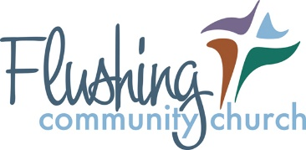
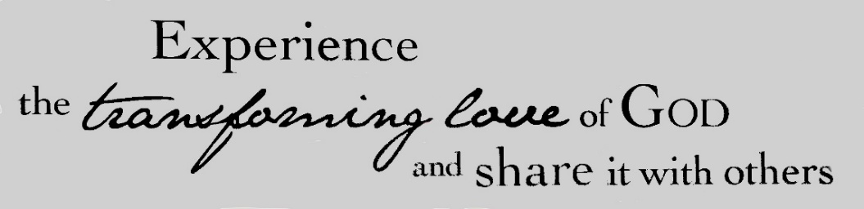
Rental and Hold Harmless Agreement

This HOLD HARMLESS AGREEMENT is made on Click here to enter a date. by and between Flushing Community Church of the Nazarene (hereinafter, FCCN), and (hereinafter, “Vendor”). FCCN and Vendor are sometimes referred to as “Party” and collectively referred to as the “Parties.”

Whereas, Vendor desires to use FCCN property located at either 9500 W. Pierson Road or 230 Oak Street on start date of Click here to enter a date. and a start time of Click here to enter text. with an end date of Click here to enter a date. and an end time of Click here to enter text.; and whereas, in exchange for making the property available to the Vendor for such purposes, Vendor agrees to hold harmless FCCN from any claims and/or litigation arising out of the Vendor’s use of the property.

Now therefore, in consideration of the mutual covenants and conditions contained herein, FCCN and Vendor agree as follows:

TERMS

- Hold Harmless: Upon Vendor’s use of the property by any of it employees, agents, invitees and/or volunteers for the purposes specified herein, Vendor shall defend, indemnify, and hold harmless FCCN from any and all actual or alleged claims, demands, causes of action, liability, loss, damage and/or injury (to property or persons, including without limitation wrongful death), whether brought by an individual or other entity, or imposed by a court of law or by administrative action of any federal, state, or local governmental body or agency, arising out of or incident to any acts, omissions, negligence, or willful misconduct of Vendor’s use of the Property. This indemnification applies to and includes, without limitation, the payment of all penalties, fines, judgements, awards, decrees, attorneys’ fees, and related costs or expenses, and any reimbursements to FCCN for all legal expenses and costs incurred by it.
- Authority to Enter Agreement: Each Party warrants that the individuals who have signed this Agreement have the legal power, right, and authority to make this Agreement and bind each respective Party.
- Amendment; Modification: No supplement, modification, or amendment of this agreement shall be binding unless executed in writing and signed by both parties.
- Waiver: No waiver of any default shall constitute a waiver of any other default or breach, whether of the same or other covenant or condition. No waiver, benefit, privilege, or service voluntarily given or performed by a Party shall give the other Party any contractual right by custom, estoppel, or otherwise.
- Attorney’s Fees and Costs: If any legal action or other proceedings is brought in connection with this Agreement, the successful or prevailing Party shall be entitled to recover reasonable attorney’s fees and other related costs, in addition to any other relief to which the Party is entitled.
- Entire Agreement: This Agreement contains the entire agreement between the Parties related to the matters specified herein, and supersedes any prior oral or written statements for agreements between the Parties related to such matters.
- Security Deposits: A $200 Security Deposit for one time use Vendors will be required for the rental of facility space. This deposit is refundable providing there is not damage at the end of the rental. The $200 deposit will be used to defray the expense of any repair or replacement costs. Damages or replacement costs exceeding $200 will be billed to the Vendor.
- Statement of Understanding: Upon my below signature I understand and agree to uphold the standards of Flushing Community Church of the Nazarene regarding its policy as a drug free, alcohol free, and tobacco free establishment.

Flushing Community Church of the Nazarene Agent: Click here to enter text.

Vendor: Name (providing my name here serves as my electronic signature) Click here to enter text.

